Assignment 1
Topic: Understanding The Connectivity Of Raspberry-Pi. Write An Application To Detect Obstacle And Notify User Using LEDs.

About Raspberry-Pi
- The Raspberry-Pi is a low cost,credit card-sized computer with an ARM processor that plugs into a computer monitor or TV, and uses a standard keyboard and mouse.
The Raspberry-Pi capable little device that enables people of all ages to explore computing, and to learn how to program in languages like Scratch and Python.
- The Raspberry-Pi capable of doing everything you’d expect a desktop computer to do, from browsing the internet and playing high-definition video, to making spreadsheets, word-processing, and playing games.
- The Raspberry-Pi has the ability to interact with the outside world, and has been used in a wide array of digital maker projects
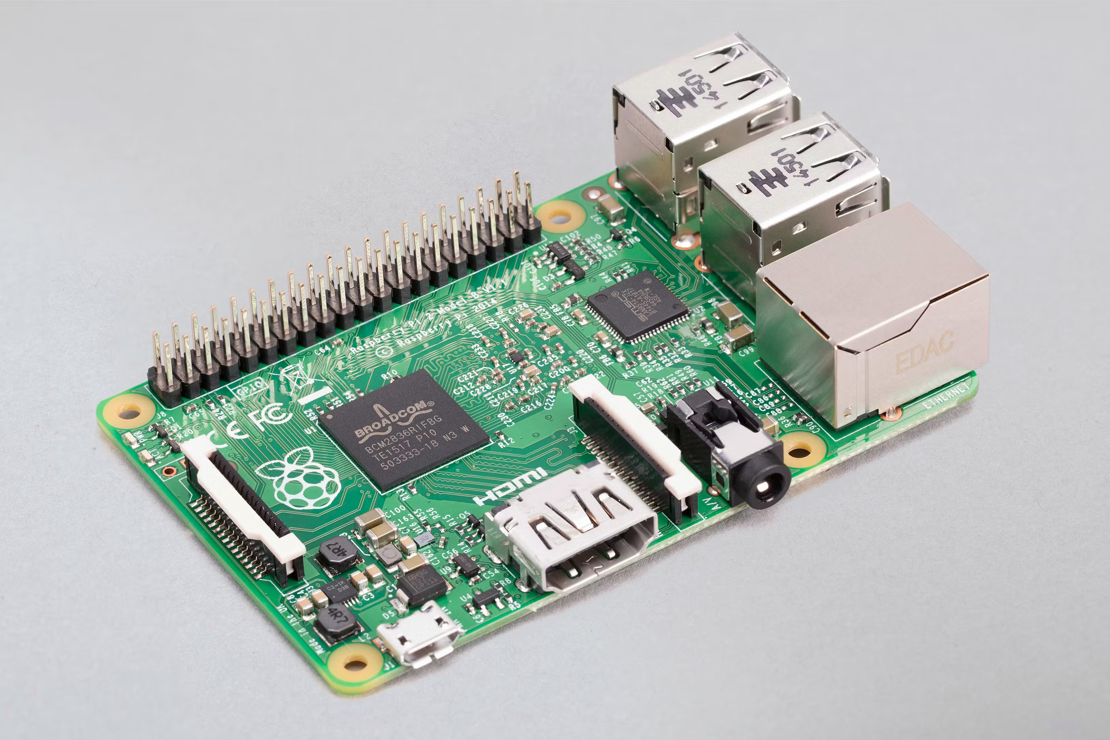

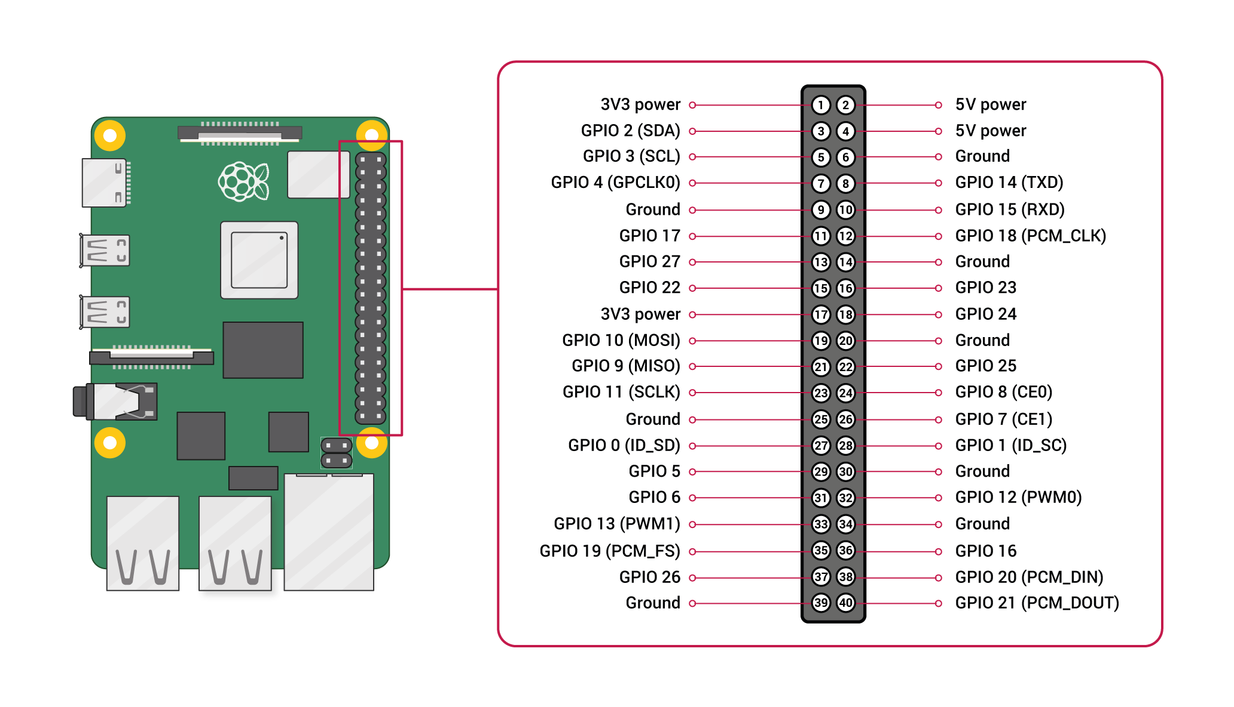
Block And Pin Diagram
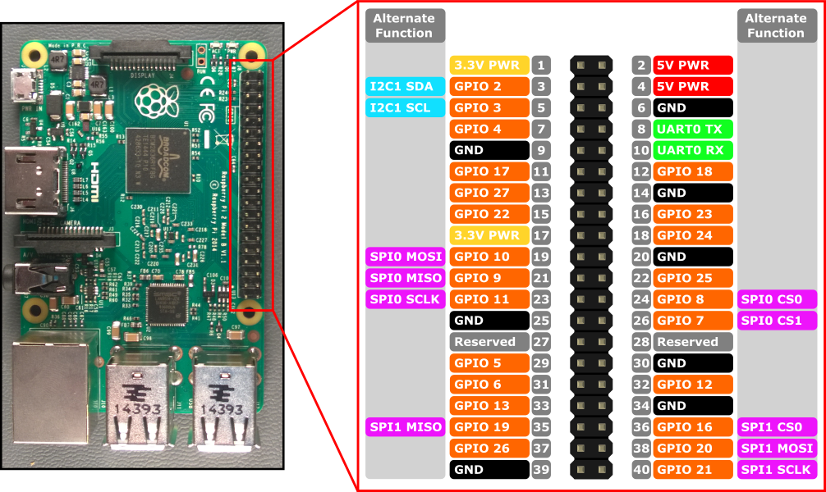

FeaturesOf Raspberry-Pi
1. Central Processing Unit (CPU)
Every computer has a Central Processing Unit, and so does the Raspberry Pi. It is the computer’s brain and carries out instructions using logical and mathematical operations. Raspberry Pi makes use of the ARM11 series processor on its boards.
2. HDMI port
Raspberry Pi board has an HDMI or High Definition Multimedia Interface port that allows the device to have video options of the output from the computer displayed. An HDMI cable connects the Raspberry Pi to an HDTV. The supported versions include 1.3 and 1.3. It also comes with an RCA port for other display options.
3. Graphic Processing Unit (GPU)
This unit, GPU or Graphic Processing Unit, is another part of the Raspberry pi board. Its primary purpose is to hasten the speed of image calculations.
4. Memory (RAM)
Random Access Memory is a core part of a computer’s processing system. It is where real-time information is stored for easy access. The initial Raspberry Pi had 256MB RAM. Over the years, developers gradually and significantly improved the size. Different Raspberry Pi models come with varying capacities. The model with the maximum capacity presently is the Raspberry Pi 4 with 8GB RAM space.
5. Ethernet port
The Ethernet port is a connectivity hardware feature available on B models of Raspberry Pi. The Ethernet port enables wired internet access to the minicomputer. Without it, software updates, web surfing, etc., would not be possible using the Raspberry Pi. The Ethernet port found on Raspberry computers uses the RJ45 Ethernet jack. With this component, Raspberry Pi can connect to routers and other devices.
6. SD card slot
Like most other regular computers, Raspberry Pi must have some sort of storage device. However, unlike conventional PCs, it does not come with a hard drive, nor does it come with a memory card. The Raspberry Pi board has a Secure Digital card or SD card slot where users must insert SD cards for the computer to function. The SD card functions like a hard drive as it contains the operating system necessary for turning the system on. It also serves to store data.
7. General Purpose Input and Output (GPIO) pins
These are upward projecting pins in a cluster on one side of the board. The oldest models of the Raspberry Pi had 26 pins, but most have 40 GPIO pins. These pins are pretty sensitive and should be handled carefully. They are essential parts of the Raspberry Pi device as they add to its diverse applications. GPIO pins are used to interact with other electronic circuits. They can read and control the electric signals from other boards or devices based on how the user programs them.
8. LEDs
These are a group of five light-emitting diodes. They signal the user on the present status of the Raspberry Pi unit.
9. USB ports
Universal service bus (USB) ports are a principal part of Raspberry Pi. They allow the computer to connect to a keyboard, mouse, hard drives, etc. The first model of Raspberry Pi had only two USB 2.0 ports. Subsequent models increased this number to four. Raspberry Pi 4 and Pi 400, much newer models, come with a mix of USB 2.0 and USB 3.0 ports.
10. Power source
Raspberry Pi has a power source connector that typically uses a 5V micro USB power cable. The amount of electricity any Raspberry Pi consumes depends on what it’s used for and the number of peripheral hardware devices connected.

Advantages Of Raspberry-pi
- The working principle is the same as the normal computer at the expense of a meager price.
- Internal or external web traffic handling can be done at a relatively very low cost.
- It works as a server and is more cost-efficient than the standard server.
- The presence of GPIO (General Purpose Input Output pins) is what distinguishes an RPI from traditional computers.
- RPI has built-in Wi-Fi and Bluetooth, allowing us to take projects into wireless mode quickly.
- The module takes only the size of your credit card.

Disanvantages Of raspberry-Pi
- It is slower in terms of CPU processing speed.
- It has as much memory as a traditional PC or laptop, which is definitely very low.
- There is no built-in analog-to-digital conversion on the GPIO pins like in an Arduino.
- It is Slow all hell
- Only HDMI CEC for remotes unless you want to build your own IR receive
- The Rpi has no fuse protection, so you can damage the board if you misconnect pins.

Uses of Raspberry Pi
Raspberry Pi has reached an unprecedented level of popularity. Originally created for educational purposes, it has become a go-to solution for tech enthusiasts looking for something to tinker with. This has led to the emergence of several relevant use cases. They are:
1. Constructing a desktop PC
One can use Raspberry Pi to construct a typical desktop personal computer. The hardware includes Raspberry Pi, a micro SD card with an operating system installed, a constant power source, and an output display device like an old monitor or television. It is also essential to have a USB mouse and keyboard. With all these, the user can work with fully functional devices for a very cheap cost.
2. Enabling media usage
Among the many uses of the Raspberry Pi, it has found profound popularity as a Kodi media player. Kodi software is a free, open-source media player that can be installed from official sites. One must install other add-ons. However, the user must be careful when using Raspberry Pi as a Kodi media center, as it can predispose the unit to security problems. This is easily prevented using a virtual private network (VPN) for data encryption.
3. Controlling IoT robots
Robotics is a vital part of today’s technology that promises to strongly influence the future, particularly the Internet of Things (IoT). Raspberry Pi, therefore, is playing a crucial role in the technology of the future. Currently, there are several robot controller Raspberry Pi projects. You can also choose to build your robot from scratch. Raspberry Pi provides the best core a robot can have. Its miniature, lightweight nature, combined with the unit’s low price, makes it simply perfect.
4. Acting as a printer server
Raspberry Pi can also be used as a printer server. This is especially important for older printers. Setting this printing server up requires installing CUPS (Common Unix Printing System) file-sharing software. CUPS gives the user access to multiple printer drivers, which should be installed depending on the type of printer.
5. Replacing web servers
One other practical application of the Raspberry Pi computer is its use as a web server. This simply means configuring the computer to be able to host HTTP websites. It can function as a web server on the internet directly or in a local network such as a home or office.
6. Converting into retro gaming machines
Users can also make Raspberry Pi into a gaming console. Without any additional modification, Minecraft comes with the default Pi operating system, Raspbian. Beyond Minecraft, other multiplayer games can also be set up on Raspberry Pi. One can achieve the best gaming experience by using multiple Raspberry Pis with one dedicated as a server.
7. Attaching to surveillance cameras
Businesses, offices, and even homes need surveillance cameras to prevent and apprehend security threats. For some, this can be very expensive, especially for small businesses. However, Raspberry Pi comes in as an excellent alternative. Combining it with a camera module allows anyone to set up their personal surveillance system.
8. Supporting digital signage
Most businesses now use digital signage to achieve a great deal of marketing. Information like the latest product, restaurant menus, adverts, appropriate behavior, maps, etc., can be displayed on large screens or specialized platforms. Raspberry Pi is not left out in this application – the minicomputer is perfect for displaying text and images.
9. Conducting network penetration tests
Computer and network security is a big deal for everyone in today’s hyperconnected society. Personal and financial information stored on various sites may get into the wrong hands. This has created a massive market for cybersecurity software. But the only way to ensure that you have adequate security is to test it. With Raspberry Pi, you can create an offensive security hacking tool to ‘attack’ your network. Any breach found is immediately repaired and closed down.
10. Providing data to business intelligence dashboards
Business intelligence dashboards, in one form or the other, are a vital part of any successful organization. It is a data visualization and analysis tool that displays the status of business metrics and key performance indicators of an organization or team. With Raspberry Pi, any business can display real-time data on a dashboard. The computer helps collect data from multiple sources using business intelligence apps like Power BI.

